E-Contents

CS

By- Suresh Jindal

Lect. ECE

**CLASSIFICATION OF RADIO TRANSMITTERS ACCORDING TO THE TYPE OF SERVICE INVOLVED:**

1. **Radio Telegraph Transmitters**: A radio telegraph transmitter transmits stele graph signals from one radio station to another radio station. It may use either amplitude modulation or frequency modulation. When point-to-point radio communication is involved, the transmitting antennas are highly directive so that the electromagnetic energy is beamed into a narrow beam directed towards the receiving antenna at the receiving radio station.
2. **Television Transmitters:** Television broadcast requires two transmitters one for transmission of picture and the other for transmission of sound. Both operate in very high frequency of in ultra-high frequency rang. The picture transmitter is amplitude modulated by the picture signal occupying a band of about 5 5MHz Vestigial transmission is used i e one full sideband and only a vestige or a part (about 0 75 MHZ) of the other sideband together with the carrier are radiated from the transmitting aerial. The total bandwidth occupied by one television channel is about 7 MHz The sound carrier is frequency modulated.
3. **Radar Transmitter:** Radar (abbreviation for Radio Detection and Ranging) may be of two types:

(i) Pulse Radar and (ii) C.W. (Continuous Wave Radar).

Pulse radar transmitter uses pulse modulation of carrier. It uses high output power typically 100 kW peak and operates at microwave frequencies typically 3000 MHz (10 cm wavelength) or 10,000 MHz (3 cm wavelength). The C.W. radar transmitter may use frequency modulation of the carrier voltage or may utilize Doppler Effect.

1. **Navigation Transmitters:** A number of navigational aids using special types of radio transmitters and receivers are used these days for sea and air navigation. Also radio aids are used for blind landing of aircrafts. Typical radio aids of landing are (a) I.L.S. (Instrumental Landing System) and (b) G.C.A. (Ground Controlled Approach). In addition to these, several other radio means are provided at airport for surveillance. Accordingly, a large number of radio transmitter of varied types, frequency and power are required depending upon the operation desired.

## CLASSIFICATION OF RADIO TRANSMITTERS ACCORDING TO THE CARRIER FREQUENCY

1. **Long Wave Transmitters:** These transmitters operate on long waves i e on frequencies below 300 kHz. Such long wave radio transmitters are used for broadcast in temperate countries, where atmospheric disturbances on long waves are not severe. Since long wave radio signals travel along the surface of earth and are rapidly attenuated, for reasonably high signal strength at the distant receiving aerial, the carrier power radiated from the transmitting aerial must be very large typically 100 kW or more.
2. **Medium Wave Transmitters:** These transmitters operate on frequencies in the range of 550 to 1650 kHz and are usually used for broadcast. Hence the band of frequency extending from 550 to 1650 kHz is commonly referred to as the Broadcast Band. The carrier power may vary from as low as 5 kW to as high as 500 to 1000kW.
3. **Short Wave Transmitters:** These transmitters operate on frequencies in the short wave range of 3 to 30MHz. In practice, frequencies beyond 24 MHz’ are not used. Ionosphere propagation of electromagnetic waves takes place at such short waves. The attenuation of radio waves travelling from the transmitting aerial to the distant receiving aerial though the ionosphere is small Hence carrier power required to be radiated from the transmitting aerial is small. For national broadcast the carrier power used may vary from about 1 to 10 kW For overseas broadcast certain amount of beaming of power is required to be done But in spite of such a beaming of energy; because of the large distance involved, the carrier power generally used is 10 to 1 00 kW. For radio telephone working over long distances on short waves, highly directive transmitting and receiving antennas are used so that carrier power required may be relatively small; of the order of 5 kW or so.

**Block diagram of AM transmitter with explanation**

AM Transmitter:

Transmitters that transmit AM signals are known as AM transmitters. These transmitters are used in medium wave (MW) and short wave (SW) frequency bands for AM broadcast. The MW band has frequencies between 550 KHz and 1650 KHz, and the SW band has frequencies ranging from 3 MHz to 30 MHz The two types of AM transmitters that are used based on their transmitting powers are:

* High Level
* Low Level

High level transmitters use high level modulation, and low level transmitters use low level modulation. The choice between the two modulation schemes depends on the transmitting power of the AM transmitter. In broadcast transmitters, where the transmitting power may be of the order of kilowatts, high level modulation is employed. In low power transmitters, where only a few watts of transmitting power are required, low level modulation is used.

High-Level and Low-Level Transmitters

Below figures show the block diagram of high-level and low-level transmitters. The basic difference between the two transmitters is the power amplification of the carrier and modulating signals.

Figure (a) shows the block diagram of high-level AM transmitter.

In high-level transmission, the powers of the carrier and modulating signals are amplified before applying them to the modulator stage, as shown in figure (a). In low-level modulation, the powers of the two input signals of the modulator stage are not amplified. The required transmitting power is obtained from the last stage of the transmitter, the class C power amplifier.

The various sections of the figure (a) are:

* + Carrier oscillator
  + Buffer amplifier
  + Frequency multiplier
  + Power amplifier
  + Audio chain
  + Modulated class C power amplifier

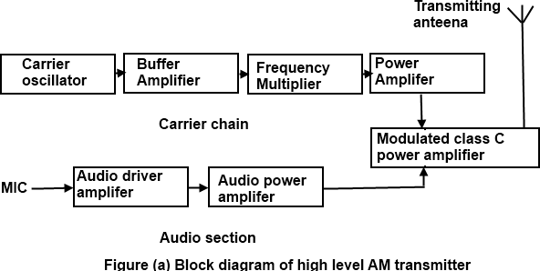

Carrier oscillator

The carrier oscillator generates the carrier signal, which lies in the RF range. The frequency of the carrier is always very high. Because it is very difficult to generate high frequencies with good frequency stability, the carrier oscillator generates a sub multiple with the required carrier frequency. This sub multiple frequency is multiplied by the frequency multiplier stage to get the required carrier frequency. Further, a crystal oscillator can be used in this stage to generate a low frequency carrier with the best frequency stability. The frequency multiplier stage then increases the frequency of the carrier to its required value.

Buffer Amplifier

The purpose of the buffer amplifier is twofold. It first matches the output impedance of the carrier oscillator with the input impedance of the frequency multiplier, the next stage of the carrier oscillator. It then isolates the carrier oscillator and frequency multiplier.

This is required so that the multiplier does not draw a large current from the carrier oscillator. If this occurs, the frequency of the carrier oscillator will not remain stable.

Frequency Multiplier

The sub-multiple frequency of the carrier signal, generated by the carrier oscillator, is now applied to the frequency multiplier through the buffer amplifier. This stage is also known as harmonic generator. The frequency multiplier generates higher harmonics of carrier oscillator frequency. The frequency multiplier is a tuned circuit that can be tuned to the requisite carrier frequency that is to be transmitted.

Power Amplifier

The power of the carrier signal is then amplified in the power amplifier stage. This is the basic requirement of a high-level transmitter. A class C power amplifier gives high power current pulses of the carrier signal at its output.

Audio Chain

The audio signal to be transmitted is obtained from the microphone, as shown in figure (a). The audio driver amplifier amplifies the voltage of this signal. This amplification is necessary to drive the audio power amplifier. Next, a class A or a class B power amplifier amplifies the power of the audio signal.

Modulated Class C Amplifier

This is the output stage of the transmitter. The modulating audio signal and the carrier signal, after power amplification, are applied to this modulating stage. The modulation takes place at this stage. The class C amplifier also amplifies the power of the AM signal to the reacquired transmitting power. This signal is finally passed to the antenna., which radiates the signal into space of transmission.

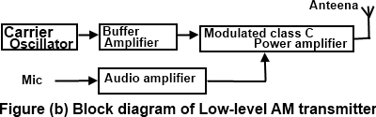

Figure shows the block diagram of a low-level AM transmitter.

The low-level AM transmitter shown in the figure (b) is similar to a high-level transmitter, except that the powers of the carrier and audio signals are not amplified. These two signals are directly applied to the modulated class C power amplifier.

Modulation takes place at the stage, and the power of the modulated signal is amplified to the required transmitting power level. The transmitting antenna then transmits the signal.

**FM transmitter**

The following image shows the block diagram of the FM transmitter and the required components of the FM transmitter are; microphone, audio pre amplifier, modulator, oscillator, RF- amplifier and antenna. There are two frequencies in the FM signal, first one is carrier frequency and the other one is audio frequency. The audio frequency is used to modulate the carrier frequency. The FM signal is obtained by differing the carrier frequency by allowing the AF. The FM transistor consists of oscillator to produce the RF signal.

### Block Diagram of FM Transmitter Working of FM Transmitter Circuit

The following circuit diagram shows the FM transmitter circuit and the required electrical and electronic components for this circuit is the power supply of 9V, resistor, capacitor, trimmer capacitor, inductor, mic, transmitter, and antenna. Let us consider the microphone to understand the sound signals and inside the mic there is a presence of capacitive sensor. It produces according to the vibration to the change of air pressure and the AC signal.

The formation of the oscillating tank circuit can be done through the transistor of 2N3904 by using the inductor and variable capacitor. The transistor used in this circuit is an NPN transistor used for general purpose amplification. If the current is passed at the inductor L1 and variable capacitor, then the tank circuit will oscillate at the resonant carrier frequency of the FM modulation. The negative feedback will be the capacitor C2 to the oscillating tank circuit.

To generate the radio frequency carrier waves the FM transmitter circuit requires an oscillator. The tank circuit is derived from the LC circuit to store the energy for oscillations. The input audio signal from the mic penetrated to the base of the transistor, which modulates the LC tank circuit carrier frequency in FM format. The variable capacitor is used to change the resonant frequency for fine modification to the FM frequency band. The modulated signal from the antenna is radiated as radio waves at the FM frequency band and the antenna is nothing but copper wire of 20cm long and 24 gauge. In this circuit the length of the antenna should be significant and here you can use the 25-27 inches long copper wire of the antenna.

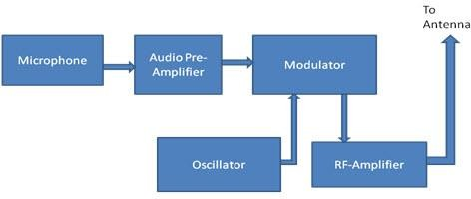

## CHAPTER-2

**Super heterodyne receiver circuit blocks**

There are some key circuit blocks that form the basic super heterodyne receiver. Although more complicated receivers can be made, the basic circuit is widely used – further blocks can add improved performance or additional functionality and their operation within the whole receiver is normally easy to determine once the basic block diagram is understood.

* RF tuning & amplification: This RF stage within the overall block diagram for the receiver provides initial tuning to remove the image signal. It also provides some amplification. If noise performance for the receiver is important, then this stage will be designed for optimum noise performance. This RF amplifier circuit block will also increase the signal level so that the noise introduced by later stages is at a lower level in comparison to the wanted signal.
* Local oscillator: The local oscillator circuit block can take a variety of forms. Early receivers used free running local oscillators. Today most receivers use frequency synthesizers, normally based around phase locked loops. These provide much greater levels of stability and enable frequencies to be programmed in a variety of ways.
* Mixer: Both the local oscillator and incoming signal enter this block within the super heterodyne receiver. The wanted signal is converted to the intermediate frequency.
* IF amplifier & filter: This super heterodyne receiver block provides the majority of gain and selectivity. High performance filters like crystal filters may be used, although LC or ceramic filters may be used within domestic radios.
* Demodulator: The super heterodyne receiver block diagram only shows one demodulator, but in reality radios may have one or more demodulators dependent upon the type of signals being receiver.
* Audio amplifier: Once demodulated, the recovered audio is applied to an audio amplifier block to be amplified to the required level for loudspeakers or headphones. Alternatively, the recovered modulation may be used for other

applications whereupon it is processed in the required way by a specific circuit block.

### Super heterodyne receiver block diagram explanation

Signals enter the receiver from the antenna and are applied to the RF amplifier where they are tuned to remove the image signal and also reduce the general level of unwanted signals on other frequencies that are not required.

The signals are then applied to the mixer along with the local oscillator where the wanted signal is converted down to the intermediate frequency. Here significant levels of amplification are applied and the signals are filtered. This filtering selects signals on one channel against those on the next. It is much larger than that employed in the front end. The advantage of the IF filter as opposed to RF filtering is that the filter can be designed for a fixed frequency. This allows for much better tuning. Variable filters are never able to provide the same level of selectivity that can be provided by fixed frequency ones.

Once filtered the next block in the super heterodyne receiver is the demodulator. This could be for amplitude modulation, single sideband, frequency modulation, or indeed any form of modulation. It is also possible to switch different demodulators in according to the mode being received.

The final element in the super heterodyne receiver block diagram is shown as an audio amplifier, although this could be any form of circuit block that is used to process or amplified the demodulated signal.

### Block diagram summary

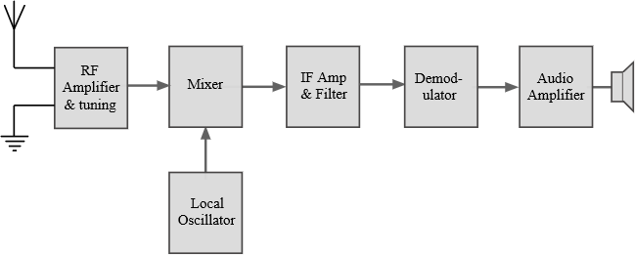

The diagram above shows a very basic version of the superhot or super heterodyne receiver. Many sets these days are far more complicated. Some superhot radios have more than one frequency conversion, and other areas of additional circuitry to provide the required levels of performance.

However, the basic super heterodyne concept remains the same, using the idea of mixing the incoming signal with a locally generated oscillation to convert the signals to a new frequency

## The parameters of the AM Receivers Are Sensitivity, Selectivity, Fidelity, Image frequency rejection etc. some of which are explained below:

### Selectively

* + The selectivity of an AM receiver is defined as its ability to accept or select the desired band of frequency and reject all other unwanted frequencies which can be interfering signals.
  + Adjacent channel rejection of the receiver can be obtained from the selectivity parameter.
  + Response of IF section, mixer and RF section considerably contribute towards selectivity.
  + The signal bandwidth should be narrow for better selectivity.
  + Graphically selectivity can be represented as a curve shown in Fig1. Below, which depicts the attenuation offered to the unwanted signals around the tuned frequency.

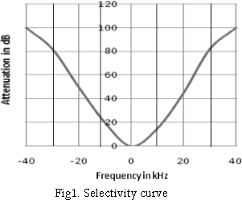

### Fidelity

* + Fidelity of a receiver is its ability to reproduce the exact replica of the transmitted signals at the receiver output.
  + For better fidelity, the amplifier must pass high bandwidth signals to amplify the frequencies of the outermost sidebands, while for better selectivity the signal should have narrow bandwidth. Thus a tradeoff is made between selectivity and fidelity.
  + Low frequency response of IF amplifier determines fidelity at the lower modulating frequencies while high frequency response of the IF amplifier determines fidelity at the higher modulating frequencies.

### Sensitivity

* + Sensitivity of a receiver is its ability to identify and amplify weak signals at the receiver output.
  + It is often defined in terms of voltage that must be applied to the input terminals of the receiver to produce a standard output power which is measured at the output terminals.
  + The higher value of receiver gain ensures smaller input signal necessary to produce the desired output power.
  + Thus a receiver with good sensitivity will detect minimum RF signal at the input and still produce utilizable demodulated signal.
  + Sensitivity is also known as receiver threshold.

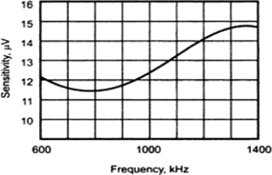

* + It is expressed in microvolts or decibels.
  + Sensitivity of the receiver mostly depends on the gain of IF amplifier.
  + It can be improved by reducing the noise level and bandwidth of the receiver.
  + Sensitivity can be graphically represented as a curve shown in Fig2. Below, which depicts that sensitivity varies over the tuning band.

Fig2. Sensitivity curve

### Double spotting

* + Double spotting is a condition where the same desired signal is detected at two nearby points on the receiver tuning dial.
  + One point is the desired point while the other is called the spurious or image point.
  + It can be used to determine the IF of an unknown receiver.
  + Poor front-end selectivity and inadequate image frequency rejection leads to double spotting.
  + Double spotting is undesirable since the strong signal might mask and overpower the weak signal at the spurious point in the frequency spectrum.
  + Double spotting can be counter acted by improving the selectivity of RF amplifier and increasing the value of IF.
  + Consider an incoming strong signal of 1000 kHz and local oscillator tuned at 1455 kHz. Thus a signal of 455 kHz is produced at the output of the mixer which is the IF frequency.

Now consider the same signal but with 545 kHz tuned local oscillator. Again we get 455 kHz signal at the output.

Therefore, the same 1000 kHz signal will appear at 1455 kHz as well as 545 kHz on the receiver dial and the image will not get rejected. This is known as Double spotting phenomenon.

* + It is also known as adjacent channel selectivity.

In radio, the **image rejection ratio**, or image frequency rejection ratio, is the ratio of (a) the intermediate-frequency (IF) signal level produced by the desired input frequency to

1. that produced by the image frequency. The image rejection ratio is usually expressed in dB when the image rejection ratio is measured, the input signal levels of the desired and image frequencies must be equal for the measurement to be meaningful.

## Selection of IF freq.

The choice of an IF frequency is one of those design trade-offs.

The lower the IF frequency used, the easier it is to achieve a narrow bandwidth to obtain good selectivity in the receiver and the greater the IF stage gain. On the other hand, the higher the IF, the further removed the image frequency is from the signal frequency and hence the better the image rejection.

One problem of the problems of a super heterodyne receiver, is its ability to pick up a second or image frequency that is twice the intermediate frequency away from the signal frequency.

For example, if we have a signal frequency of 1 MHz which is mixed with an IF of 455 kHz. A second or image signal, with a frequency equal to 1 MHz plus (2 x 455) kHz or 1.910 MHz, can also mix with the 1.455 MHz to produce the 455 kHz.

The choice of IF is also affected by the selectivity of the RF end of the receiver. If the receiver has a number of RF stages, it is better able to reject an image signal close to the signal frequency and hence a lower IF channel can be tolerated. This is why modern rigs have 2 or even 3 IF stages.

The chosen IF frequency should be free from radio interference. Standard intermediate frequencies have been established and these are kept dear of signal channel allocation.

As you have noted, 455 KHz is a common IF. This is because broadcasters settled on this as a standard frequency during the broadcast AM days.

From a design point of view 455KHz it leads to poor image response when used above 10 MHz One commonly used IF for shortwave receivers is 1.600 MHz and this gives a much improved image response for the HF spectrum. Ham band SSB HF transceivers have commonly used 9 MHz as a receiver intermediate frequency

This frequency is a little high for ordinary tuned circuits to achieve the narrow bandwidth needed in speech communication, however, when used with ceramic crystal filter networks it leads to good results.

Some recent amateur transceivers use intermediate frequencies slightly below 9 MHz A frequency of 8.830 MHz can be found in various Kenwood transceivers and a frequency of 8.987.5 MHz in some Yaesu transceivers. This change could possibly be to avoid the second harmonic of the IF falling too near the edge of the 17m WARC band

## Simple & Delayed AGC

Automatic gain control (AGC) is a mechanism wherein the overall gain of the radio receiver is automatically varied according to the changing strength of the received signal. This is done to maintain the output at a constant level. If the gain is not varied as per the input signal, consider a stronger input signal, then the signal might probably be distorted with some of the amplifiers reaching saturation level. AGC is applied to the RF, IF and mixer stages, which also helps in improving the dynamic range of the receiver antenna to 60-100 dB by adjusting the gain of the various stages in the radio receiver. The AGC derives dc bias voltage from the part of the detected signal to apply to the RF, IF and mixer stages to control their gains. The Trans conductance and hence the gain of the devices used in these stages of the receiver depends on the applied bias voltage or current. When the overall signal level increases, the value of the applied AGC bias increase leading to the

decrease in the gain of the controlled stages. When there is no signal or signal with low value, there is minimum AGC bias which results in amplifier generating maximum gain. AGC facilitates tuning to varying signal strength stations providing a constant output. AGC smoothens the amplitude variations of the input signal and the gain control does not have to be recalibrated every time the receiver is tuned from station to station. An AGC which is not designed correctly can lead to considerable distortion to a smooth signal.

*There are two types of AGC circuits*:

* + Simple AGC: the gain control mechanism is active for high as well as low value of carrier voltage.
  + Delayed AGC: AGC bias is not applied to the amplifiers until signal strength crosses a predetermined level, after which AGC bias is applied.

## FM RECEIVER

### RF section

* + Consists of a pre-selector and an amplifier
  + Pre-selector is a broad-tuned band pass filter with an adjustable center frequency used to reject unwanted radio frequency and to reduce the noise bandwidth.
  + RF amplifier determines the sensitivity of the receiver and a predominant factor

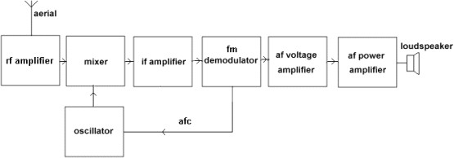

in determining the noise figure for the receiver.

### Mixer/converter section

* + Consists of a radio-frequency oscillator and a mixer.
  + Choice of oscillator depends on the stability and accuracy desired.
  + Mixer is a nonlinear device to convert radio frequency to intermediate frequencies (i.e. heterodyning process).

The shape of the envelope, the bandwidth and the original information contained in the envelope remains unchanged although the carrier and sideband frequencies are translated from RF to IF.

### IF section

* + Consists of a series of IF amplifiers and band pass filters to achieve most of the receiver gain and selectivity.
  + The IF is always lower than the RF because it is easier and less expensive to construct high-gain, stable amplifiers for low frequency signals.
  + IF amplifiers are also less likely to oscillate than their RF counterparts.

### Detector section

* + To convert the IF signals back to the original source information (demodulation).
  + Can be as simple as a single diode or as complex as a PLL or balanced demodulator.

### Audio amplifier section

* + Comprises several cascaded audio amplifiers and one or more speakers

### AGC (Automatic Gain Control)

* + Adjust the IF amplifier gain according to signal level (to the average amplitude signal almost constant).
  + AGC is a system by means of which the overall gain of radio receiver is varied automatically with the variations in the strength of received signals, to maintain the output constant.
  + AGC circuit is used to adjust and stabilize the frequency of local oscillator. Types of AGC –No AGC, Simple AGC, Delayed AGC.

## CHAPTER-3

**EM spectrum**

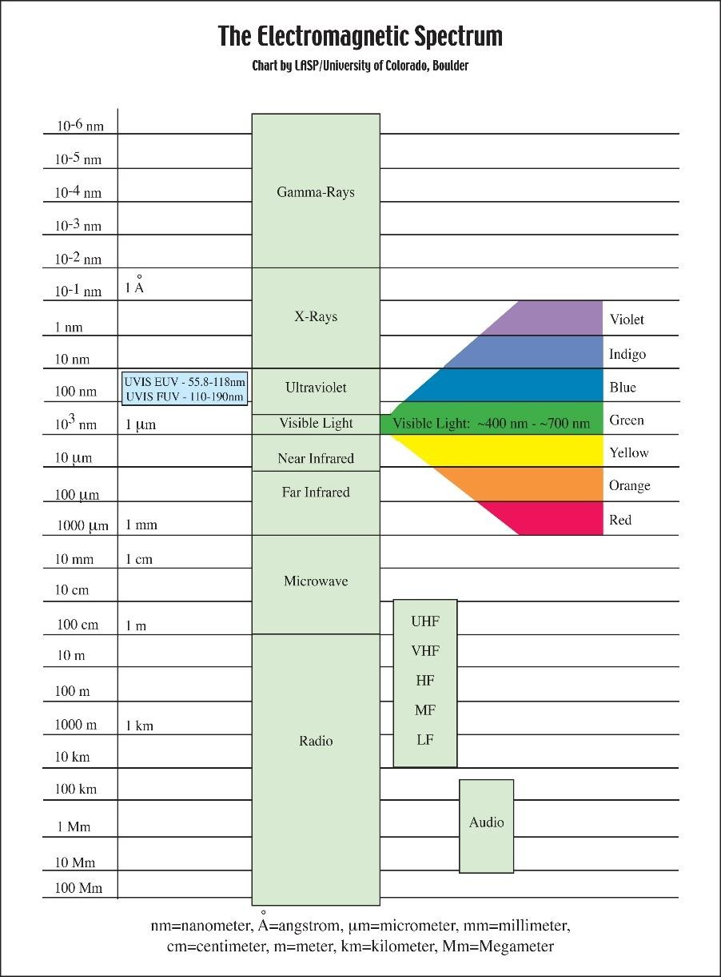The electromagnetic spectrum is the range of frequencies (the spectrum) of electromagnetic radiation and their respective wavelengths and photon energies.

The electromagnetic spectrum covers electromagnetic waves with frequencies ranging from below one hertz to above 1025 hertz, corresponding to wavelengths from thousands of kilometres down to a fraction of the size of an atomic nucleus. This frequency range is divided into separate bands, and the electromagnetic waves within each frequency band are called by different names; beginning at the low frequency (long wavelength) end of the

spectrum these are: radio waves, microwaves, infrared, visible light, ultraviolet, X-rays, and gamma rays at the high-frequency (short wavelength) end. The electromagnetic waves in each of these bands have different characteristics, such as how they are produced, how they interact with matter, and their practical applications. The limit for long wavelengths is the size of the universe itself, while it is thought that the short wavelength limit is in the vicinity of the Planck length. Gamma rays, X-rays, and high ultraviolet are classified as ionizing radiation as their photons have enough energy to ionize atoms, causing chemical reactions. Exposure to these rays can be a health hazard, causing radiation sickness, DNA damage and cancer. Radiation of visible light wavelengths and lower are called nonionizing radiation as they cannot cause these effects.

In most of the frequency bands above, a technique called spectroscopy can be used to physically separate waves of different frequencies, producing a spectrum showing the constituent frequencies. Spectroscopy is used to study the interactions of electromagnetic waves with matter. Other technological uses are described under electromagnetic radiation.

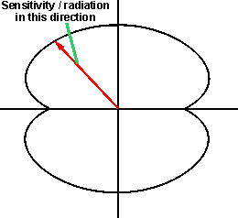

# The radiation pattern of a dipole antenna is of particular importance.

The radiation pattern reflects the 'sensitivity' of the antenna in different directions and a knowledge of this allows the antenna to be orientated in the optimum direction to ensure the required performance.

Radiation pattern and polar diagram

The radiation pattern of any antenna can be plotted. This is plotted onto a polar diagram. A polar diagram is a plot that indicates the magnitude of the response in any direction.

At the centre of the diagram is a point of referred to as the origin. This is surrounded by a curve whose radius at any given point is proportional to the magnitude of the property measured in the direction of that point.

### Antenna polar diagram concept

Polar diagrams are used for plotting the radiation patterns of antennas as well as other applications like measuring the sensitivity of microphones in different directions, etc.

The radiation pattern shown on a polar diagram is taken to be that of the plane in which the diagram plot itself. For a dipole it is possible to look at both the along the axis of the antenna and also at right angles to it. Normally these would be either vertical or horizontal planes.

One fundamental fact about antenna radiation patterns and polar diagrams is that the receiving pattern, i.e. the receiving sensitivity as a function of direction is identical to the far-field radiation pattern of the antenna when used for transmitting. This results from the reciprocity theorem of electromagnetics. Accordingly, the radiation patterns the antenna can be viewed as either transmitting or receiving, whichever is more convenient.

### Half wave dipole radiation pattern

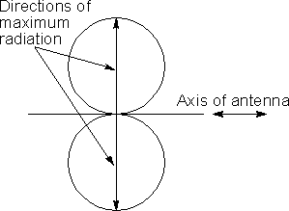The radiation pattern of a half wave dipole antenna that the direction of maximum sensitivity or radiation is at right angles to the axis of the RF antenna. The radiation falls to zero along the axis of the RF antenna as might be expected.

### Radiation pattern of a half wave dipole antenna in free space

In a three dimensional plot, the radiation pattern envelope for points of equal radiation intensity for a doughnut type shape, with the axis of the antenna passing through the hole in the centre of the doughnut.

Radiation patterns for multiple half wavelength dipoles

If the length of the dipole antenna is changed from a half wavelength, then the radiation pattern is altered. As the length of the antenna is extended it can be seen that the familiar

figure of eight pattern changes to give main lobes and a few side lobes. The main lobes move progressively towards the axis of the antenna as the length increases.

# Polarization of waves

Polarization, also called wave polarization, is an expression of the orientation of the lines of electric flux in an electromagnetic field (EM field). Polarization can be constant -- that is, existing in a particular orientation at all times, or it can rotate with each wave cycle.

Polarization is important in wireless communications systems. The physical orientation of a wireless antenna corresponds to the polarization of the radio waves received or transmitted by that antenna. Thus, a vertical antenna receives and emits vertically polarized waves, and a horizontal antenna receives or emits horizontally polarized waves. The best short-range communications are obtained when the transmitting and receiving (source and destination) antennas have the same polarization. The least efficient short-range communications usually take place when the two antennas are at right angles (for example, one horizontal and one vertical). Over long distances, the atmosphere can cause the polarization of a radio wave to fluctuate, so the distinction between horizontal and vertical becomes less significant.

Some wireless antennas transmit and receive EM waves whose polarization rotates 360 degrees with each complete wave cycle. This type of polarization, called elliptical or circular polarization, can be either clockwise or counter clockwise. The best communications results are obtained when the transmitting and receiving antennas have the same sense of polarization (both clockwise or both counter clockwise). The worst communications usually take place when the two antennas radiate and receive in the opposite sense (one clockwise and the other counter clockwise).

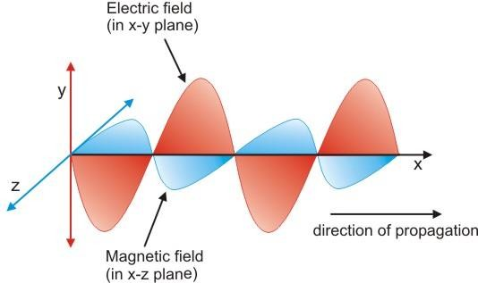

Polarization affects the propagation of EM fields at infrared (IR), visible, ultraviolet (UV), and even X-ray wavelength s. In ordinary visible light, there are numerous wave components at random polarization angles. When such light is passed through a special filter, the filter blocks all light except that having a certain polarization. When two polarizing filters are placed so a ray of light passes through them both, the amount of light transmitted depends on the angle of the polarizing filters with respect to each other. The most light is transmitted when the two filters are oriented so they polarize light in the same direction. The least light is transmitted when the filters are oriented at right angles to each other.

## Point source

Radio wave sources which are smaller than one radio wavelength are also generally treated as point sources. Radio emissions generated by a fixed electrical circuit are usually polarized, producing anisotropic radiation. If the propagating medium is lossless, however, the radiant power in the radio waves at a given distance will still vary as the inverse square of the distance if the angle remains constant to the source polarization.

## Directive gain or directivity

Is a different measure which does not take an antenna's electrical efficiency into account? This term is sometimes more relevant in the case of a receiving antenna where one is concerned mainly with the ability of an antenna to receive signals from one direction while rejecting interfering signals coming from a different direction.

## Power gain

Power gain (or simply gain) is a unit less measure that combines an antenna's efficiency Antenna and directivity D.

*G = E antenna. D*

## Aperture

In electromagnetics and antenna theory, antenna aperture, effective area, or receiving cross section, is a measure of how effective an antenna is at receiving the power of electromagnetic radiation (such as radio waves). The aperture is defined as the area, oriented perpendicular to the direction of an incoming electromagnetic wave, which would intercept the same amount of power from that wave as is produced by the antenna

receiving it. At any point, a beam of electromagnetic radiation has an irradiance or power flux density (PFD) which is the amount of energy passing through a unit area of one square meter



## Effective aperture

The effective antenna aperture/area is a theoretical value which is a measure of how effective an antenna is at receiving power. The effective aperture/area can be calculated by knowing the gain of the receiving antenna.

Where,

Ae = Effective Antenna Aperture

λ = Wavelength = C/F (where f = frequency, C = speed of light) G= Antenna gain (Linear Value)

## Radiation Pattern

The energy radiated by an antenna is represented by the Radiation pattern of the antenna. Radiation Patterns are diagrammatical representations of the distribution of radiated energy into space, as a function of direction.

The radiation patterns can be field patterns or power patterns.

The field patterns are plotted as a function of electric and magnetic fields. They are plotted on logarithmic scale.

The power patterns are plotted as a function of square of the magnitude of electric and magnetic fields. They are plotted on logarithmic or commonly on dB scale.

## Beam width

In a radio antenna pattern, the half power beam width is the angle between the half- power (-3 dB) points of the main lobe, when referenced to the peak effective radiated power of the main lobe. See beam diameter. Beam width is usually but not always expressed in degrees and for the horizontal plane.

Radiation resistance is that part of an antenna's feed point resistance that is caused by the radiation of electromagnetic waves from the antenna, as opposed to loss resistance (also called ohmic resistance) which generally causes the antenna to heat up. The total of radiation resistance and loss resistance is the electrical resistance of the antenna.

## Radiation resistance

The radiation resistance is determined by the geometry of the antenna, where loss resistance is primarily determined by the materials of which it is made. While the energy lost by ohmic resistance is converted to heat, the energy lost by radiation resistance is converted to electromagnetic radiation.

Radiation resistance is caused by the radiation reaction of the conduction electrons in the antenna.

## Half wave dipole

The dipole antenna is cut and bent for effective radiation. The length of the total wire, which is being used as a dipole, equals half of the wavelength (i.e., l = λ/2). Such an antenna is called as **half-wave dipole antenna**. This is the most widely used antenna because of its advantages. It is also known as **Hertz antenna**.

### Frequency range

The range of frequency in which half-wave dipole operates is around 3 KHz to 300GHz. This is mostly used in radio receivers.

**Construction & Workingof Half-Wave Dipole**

It is a normal dipole antenna, where the frequency of its operation is **half of its wavelength**. Hence, it is called as half-wave dipole antenna.

The edge of the dipole has maximum voltage. This voltage is alternating (AC) in nature. At the positive peak of the voltage, the electrons tend to move in one direction and at the negative peak, the electrons move in the other direction. This can be explained by the

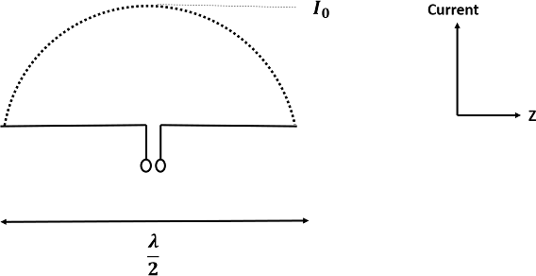

figures given below.

The figures given above show the working of a half-wave dipole.

* + Fig 1 shows the dipole when the charges induced are in positive half cycle. Now the electrons tend to move towards the charge.
  + Fig 2 shows the dipole with negative charges induced. The electrons here tend to

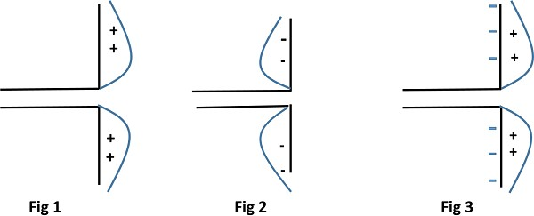

move away from the dipole.

* + Fig 3 shows the dipole with next positive half cycle. Hence, the electrons again move towards the charge.

The cumulative effect of this produces a varying field effect which gets radiated in the same pattern produced on it. Hence, the output would be an effective radiation following the cycles of the output voltage pattern. Thus, a half-wave dipole **radiates effectively**.

The above figure shows the current distribution in half wave dipole. The directivity of half wave dipole is 2.15dBi, which is reasonably good. Where, ‘I’ represents the isotropic radiation.

Radiation Pattern

The radiation pattern of this half-wave dipole is **Omni-directional** in the H-plane. It is desirable for many applications such as mobile communications, radio receivers etc.

The above figure indicates the radiation pattern of a half wave dipole in both H-plane and V-plane.

The radius of the dipole does not affect its input impedance in this half wave dipole, because the length of this dipole is half wave and it is the first resonant length. An antenna works effectively at its **resonant frequency**, which occurs at its resonant length.

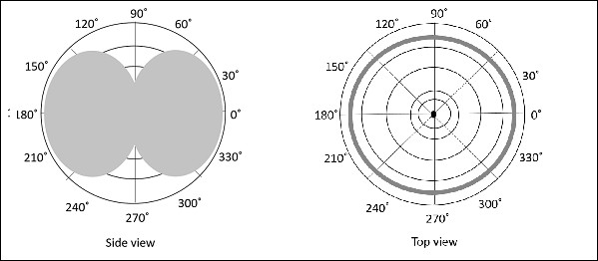

### Advantages

The following are the advantages of half-wave dipole antenna −

* + Input impedance is not sensitive.
  + Matches well with transmission line impedance.
  + Has reasonable length.
  + Length of the antenna matches with size and directivity.

### Disadvantages

The following are the disadvantages of half-wave dipole antenna −

* + Not much effective due to single element.
  + It can work better only with a combination.

### Applications

The following are the applications of half-wave dipole antenna −

* + Used in radio receivers.
  + Used in television receivers.
  + When employed with others, used for wide variety of applications.

**Folded dipole antenna**

In its basic form the folded dipole antenna consists of a basic dipole with an added conductor connecting the two ends together to make a complete loop of wire or other conductor. As the ends appear to be folded back, the antenna is called a folded dipole.

The basic format for the folded dipole aerial is shown below. As can be seen from this it is a balanced antenna, like the standard dipole, although it can be fed with unbalanced feeder provided that a balun of some form is used to transform from an unbalanced to balance feed structure.

### Half wave dipole antenna

The folded dipole antenna uses an extra wire connecting both ends of the previous dipole as shown. Often this is achieved by using a wire or rod of the same diameter for all sections of the antenna, but this is not always the case.

Also the wires or rods are typically equi-spaced along the length of the parallel elements. This can be achieved in a number of ways. Often for VHF or UHF antennas the rigidity of the elements is sufficient, but at lower frequencies spacers may need to be employed. To

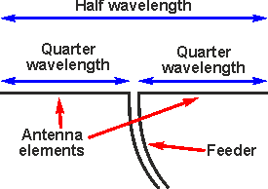

keep the wires apart. Obviously if they are not insulated it is imperative to keep them from shorting. In some instances, flat feeder can be used.

**Half-wave folded dipole antenna**

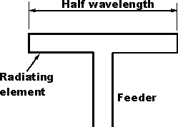

One of the main reasons for using the folded dipole aerial is the increase in feed impedance that it provides. If the conductors in the main dipole and the second or "fold" conductor are the same diameter, then it is found that there is a fourfold increase (i.e. two squared) in the feed impedance. In free space, this gives an increase in feed impedance from 73Ω to around 300Ω ohms. Additionally, the RF antenna has a wider bandwidth.

### Loop antenna

A loop antenna is a radio antenna consisting of a loop or coil of wire, tubing, or other electrical conductor usually fed by a balanced source or feeding a balanced load. Within this physical description there are two distinct antenna types. The large self-resonant loop antenna has a circumference close to one wavelength of the operating frequency and so is resonant at that frequency. This category also includes smaller loops 5% to 30% of a wavelength in circumference, which use a capacitor to make them resonant. These antennas are used for both transmission and reception. In contrast, small loop antennas less than 1% of a wavelength in size are very inefficient radiators, and so are only used for reception. An example is the ferrite (loop stick) antenna used in most AM broadcast radios. Loop antennas have a dipole radiation pattern; they are most sensitive to radio

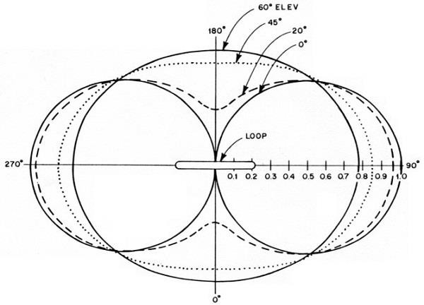

waves in two broad lobes in opposite directions, 180° apart. Due to this directional pattern they are used for radio direction finding (RDF), to locate the position of a transmitter.

*Radiation Pattern*

The radiation pattern of these antennas will be same as that of short horizontal dipole antenna.

The radiation pattern for small, high-efficiency loop antennas is shown in the figure given above. The radiation patterns for different angles of looping are also illustrated clearly in the figure. The tangent line at 0° indicates vertical polarization, whereas the line with 90° indicates horizontal polarization.

Advantages

The following are the advantages of Loop antenna −

* + Compact in size
  + High directivity Disadvantages
  + The following are the disadvantages of Loop antenna −
  + Impedance matching may not be always good
  + Has very high resonance quality factor Applications
  + The following are the applications of Loop antenna −
  + Used in RFID devices
  + Used in MF, HF and Short wave receivers
  + Used in Aircraft receivers for direction finding
  + Used in UHF transmitters

## Yagi Antenna / Yagi-Uda Antenna

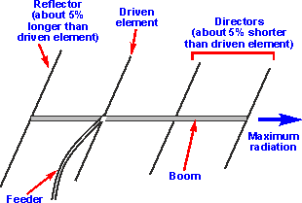The Yagi antenna or Yagi-Uda antenna / aerial is one of the most successful RF antenna designs for directive antenna applications. The Yagi or Yagi-Uda antenna is used in a wide variety of applications where an RF antenna design with gain and directivity is required. The Yagi has become particularly popular for television reception, but it is also used in very many other domestic and commercial applications where an RF antenna is needed that has gain and directivity. Not only is the gain of the Yagi antenna important as it enables better levels of signal to noise ratio to be achieved, but also the directivity can be

used to reduce interference levels by focussing the transmitted power on areas where it is needed, or receiving signals best from where the emanate.

*Yagi antenna - the basics*

The Yagi antenna design has a dipole as the main radiating or driven element. Further 'parasitic' elements are added which are not directly connected to the driven element.

These parasitic elements within the Yagi antenna pick up power from the dipole and re- radiate it. The phase is in such a manner that it affects the properties of the RF antenna as a whole, causing power to be focussed in one particular direction and removed from others.

The parasitic elements of the Yagi antenna operate by re-radiating their signals in a slightly different phase to that of the driven element. In this way the signal is reinforced in some directions and cancelled out in others. It is found that the amplitude and phase of the current that is induced in the parasitic elements is dependent upon their length and the spacing between them and the dipole or driven element.

There are three types of element within a Yagi antenna:

* + Driven element: The driven element is the Yagi antenna element to which power is applied. It is normally a half wave dipole or often a folded dipole.
  + Reflector: The Yagi antenna will generally only have one reflector. This is behind the main driven element, i.e. the side away from the direction of maximum sensitivity.

Further reflectors behind the first one adds little to the performance. However, many designs use reflectors consisting of a reflecting plate, or a series of parallel rods simulating a reflecting plate. This gives a slight improvement in performance, reducing the level of radiation or pick-up from behind the antenna, i.e. in the backwards direction.

Typically, a reflector will add around 4 or 5 dB of gain in the forward direction.

* + Director: There may be none, one of more reflectors in the Yagi antenna. The director or directors are placed in front of the driven element, i.e. in the direction of maximum sensitivity. Typically, each director will add around 1 dB of gain in the forward direction, although this level reduces as the number of director’s increases.

The antenna exhibits a directional pattern consisting of a main forward lobe and a number of spurious side lobes. The main one of these is the reverse lobe caused by radiation in the direction of the reflector. The antenna can be optimised to either reduce this or produce the maximum level of forward gain. Unfortunately, the two do not coincide exactly and a compromise on the performance has to be made depending upon the application.

Yagi antenna advantages

* + The Yagi antenna offers many advantages for its use. The antenna provides many advantages in a number of applications:
  + Antenna has gain allowing lower strength signals to be received.
  + Yagi antenna has directivity enabling interference levels to be minimised.
  + 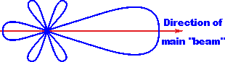Straightforward construction. - The Yagi antenna allows all constructional elements to be made from rods simplifying construction.
  + The construction enables the antenna to be mounted easily on vertical and other poles with standard mechanical fixings

The Yagi antenna also has a number of disadvantages that need to be considered.

* + For high gain levels the antenna becomes very long
  + Gain limited to around 20dB or so for a single antenna

The Yagi antenna is a particularly useful form of RF antenna design. It is widely used in applications where an RF antenna design is required to provide gain and directivity. In this way the optimum transmission and reception conditions can be obtained.

### Ferrite rod antenna

The ferrite rod antenna is a form of RF antenna design that is almost universally used in portable transistor broadcast receivers as well as many hi-fi tuners where reception on the long, medium and possibly the short wave bands is required.

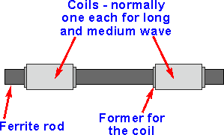Ferrite rod antennas are also being used increasingly in wireless applications in areas such as RFID. Here the volumes of antennas required can be huge. The antennas also need

to be compact and effective, making ferrite rod antennas an ideal solution. Ferrite rod antenna basics

As the name suggests the antenna consists of a rod made of ferrite, an iron based magnetic material. A coil is would around the ferrite rod and this is brought to resonance using a variable tuning capacitor contained within the radio circuitry itself and in this way the antenna can be tuned to resonance. As the antenna is tuned it usually forms the RF tuning circuit for the receiver, enabling both functions to be combined within the same components, thereby reducing the number of components and hence the cost of the set.

### Typical ferrite rod antenna assembly used in a portable radio

The ferrite rod antenna operates using the high permeability of the ferrite material and in its basic form this may be thought of as "concentrating" the magnetic component of the radio waves. This is brought about by the high permeability μ of the ferrite.

The fact that this RF antenna uses the magnetic component of the radio signals in this way means that the antenna is directive. It operates best only when the magnetic lines of force fall in line with the antenna. This occurs when it is at right angles to the direction of the transmitter. This means that the antenna has a null position where the signal level is at a minimum when the antenna is in line with the direction of the transmitter.

### Operation of a ferrite rod antenna

Ferrite rod antenna performance

This form of RF antenna design is very convenient for portable applications, but its efficiency is much less than that of a larger RF antenna. The performance of the ferrite also limits the frequency response. Normally this type of RF antenna design is only

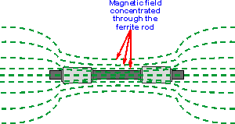

effective on the long and medium wave bands, but it is sometimes used for lower frequencies in the short wave bands although the performance is significantly degraded, mainly arising from the losses in the ferrite. This limits their operation normally to frequencies up to 2 or 3 MHz

Ferrite rod antennas are normally only used for receiving. They are rarely used for transmitting anything above low levels of power in view of their poor efficiency. It any reasonable levels of power were fed into them they would soon become very hot and there would be a high likelihood that they would be destroyed. Nevertheless, they can be used as a very compact form of transmitting antenna for applications where efficiency is not an issue and where power levels are very low. As they are very much more compact

than other forms of low or medium frequency RF antenna, this can be an advantage, and as a result they are being used in applications such as RFID.

## Parabolic antenna

A parabolic antenna is an antenna that uses a parabolic reflector, a curved surface with the cross-sectional shape of a parabola, to direct the radio waves. The most common form is shaped like a dish and is popularly called a dish antenna or parabolic dish. The main advantage of a parabolic antenna is that it has high directivity. It functions similarly to a searchlight or flashlight reflector to direct the radio waves in a narrow beam, or receive radio waves from one particular direction only. Parabolic antennas have some of the highest gains, meaning that they can produce the narrowest beam widths, of any antenna type. In order to achieve narrow beam widths, the parabolic reflector must be much larger than the wavelength of the radio waves used, so parabolic antennas are used in the high frequency part of the radio spectrum, at UHF and microwave (SHF) frequencies, at which the wavelengths are small enough that conveniently-sized reflectors can be used.

Parabolic antennas are used as high-gain antennas for point-to-point communications, in applications such as microwave relay links that carry telephone and television signals between nearby cities, wireless WAN/LAN links for data communications, satellite communications and spacecraft communication antennas. They are also used in radio telescopes.

The other large use of parabolic antennas is for radar antennas, in which there is a need to transmit a narrow beam of radio waves to locate objects like ships, airplanes, and guided missiles, and often for weather detection. With the advent of home satellite television receivers, parabolic antennas have become a common feature of the landscapes of modern countries.

The parabolic antenna was invented by German physicist Heinrich Hertz during his discovery of radio waves in 1887. He used cylindrical parabolic reflectors with spark- excited dipole antennas at their focus for both transmitting and receiving during his historic experiments.

## CHAPTER-4

**Surface Waves**

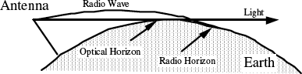

These are the principle waves used in AM, FM and TV broadcast. Objects such as buildings, hills, ground conductivity, etc. have a significant impact on their strength. Surface waves are usually vertically polarized with the electric field lines in contact with the earth.



### Refraction

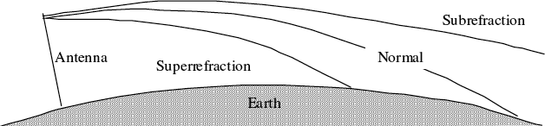

Because of refraction, the radio horizon is larger than the optical horizon by about 4/3. The typical maximum direct wave transmission distance (in km) is dependent on the height of the transmitting and receiving antennas (in meters):

However, the atmospheric conditions can have a dramatic effect on the amount of refraction.

### Super Refraction

In super refraction, the rays bend more than normal thus shortening the radio horizon. This phenomenon occurs when temperature increases but moisture decreases with

height. Paradoxically, in some cases, the radio wave can travel over enormous distances. It can be reflected by the earth, rebroadcast and super refracted again.

### Sub refraction

In sub refraction, the rays bend less than normal. This phenomenon occurs when temperature decreases but moisture increases with height. In extreme cases, the radio signal may be refracted out into space.

## Space Waves

These waves occur within the lower 20 km of the atmosphere, and are comprised of a direct and reflected wave. The radio waves having high frequencies are basically called as space waves. These waves have the ability to propagate through atmosphere, from transmitter antenna to receiver antenna. These waves can travel directly or can travel after reflecting from earth’s surface to the troposphere surface of earth. So, it is also called

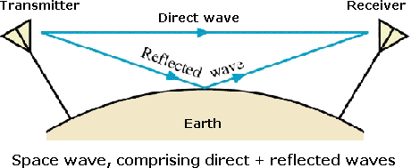

as Tropospheric Propagation. In the diagram of medium wave propagation, c shows the space wave propagation. Basically the technique of space wave propagation is used in bands having very high frequencies. E.g. V.H.F. band, U.H.F band etc. At such higher frequencies the other wave propagation techniques like sky wave propagation, ground wave propagation can’t work. Only space wave propagation is left which can handle frequency waves of higher frequencies. The other name of space wave propagation is line of sight propagation. There are some limitations of space wave propagation.

1. These waves are limited to the curvature of the earth.
2. These waves have line of sight propagation, means their propagation is along the line of sight distance.

The line of sight distance is that exact distance at which both the sender and receiver antenna are in sight of each other. So, from the above line it is clear that if we want to increase the transmission distance then this can be done by simply extending the heights of both the sender as well as the receiver antenna. This type of propagation is used basically in radar and television communication.

The frequency range for television signals is nearly 80 to 200 MHz these waves are not reflected by the ionosphere of the earth. The property of following the earth’s curvature is also missing in these waves. So, for the propagation of television signal, geostationary satellites are used. The satellites complete the task of reflecting television signals towards earth. If we need greater transmission, then we have to build extremely tall antennas.

### Direct Wave

This is generally a line of sight transmission, however, because of atmospheric refraction the range extends slightly beyond the horizon.

### Ground Reflected Wave

Radio waves may strike the earth, and bounce off. The strength of the reflection depends on local conditions. The received radio signal can cancel out if the direct and reflected waves arrive with the same relative strength and 180o out of phase with each other.

Horizontally polarized waves are reflected with almost the same intensity but with an 180o phase reversal.

Vertically polarized waves generally reflect less than half of the incident energy. If the angle of incidence is greater than 10o there is very little change in phase angle.

## Sky Waves

These waves head out to space but are reflected or refracted back by the ionosphere. The height of the ionosphere ranges from 50 to 1,000 km. Radio waves are refracted by the ionized gas created by solar radiation. The amount of ionization depends on the time of day, season and the position in the 11-year sun spot cycle. The specific radio frequency refracted is a function of electron density and launch angle. A communication channel thousands of kilometres long can be established by successive reflections at the earth’s surface and in the upper atmosphere. This ionosphere propagation takes place mainly in

the HF band. The ionosphere is composed of several layers, which vary according to the time of day. Each layer has different propagation characteristics:

* + D layer – This layer occurs only during the day at altitudes of 60 to 90 km. High absorption takes place at frequencies up to 7 MHz
  + E layer – This layer occurs at altitudes of 100 to 125 km. In the summer, dense ionization clouds can form for short periods. These clouds called *sporadic E* can refract radio signals in the VHF spectrum. This phenomenon allows amateur radio operators to communicate over enormous distances.
  + F layer - This single night-time layer splits into two layers (F1 and F2) during the day. The F1 layer forms at about 200 km and F2 at about 400 km. The F2 layer propagates most HF short-wave transmissions.

Because radio signals can take many paths to the receiver, multipath fading can occur. If the signals arrive in phase, the result is a stronger signal. If they arrive out of phase with each other, they tend to cancel. Deep fading, lasting from minutes to hours over a wide frequency range, can occur when solar flares increase the ionization in the D layer. The useful transmission band ranges between the LUF (lowest usable frequency) and MUF (maximum usable frequency). Frequencies above the MUF are refracted into space. Below the LUF, radio frequencies suffer severe absorption. If a signal is near either of these two extremes, it may be subject to fading. Meteors create ionization trails that reflect radio waves. Although these trails exist for only a few seconds, they have been successfully used in communications systems spanning 1500 km. The Aurora Borealis or Northern Lights cause random reflection in the 3 - 5 MHz region. Aurora causes signal flutter at 100 Hz to 2000 Hz thus making voice transmission impossible.

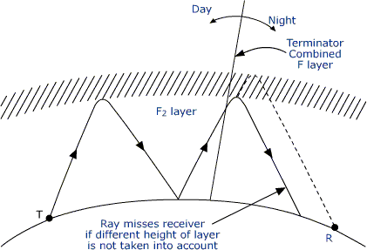

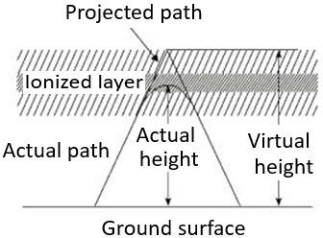

## Ionosphere

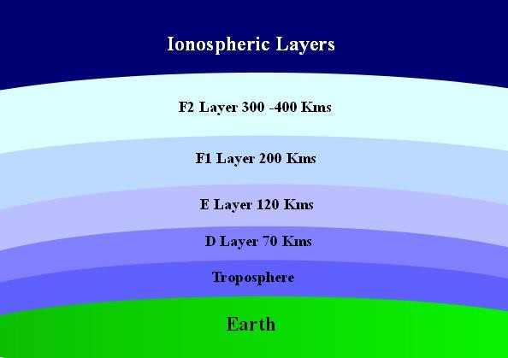The ionosphere is the ionized part of Earth's upper atmosphere, from about 60 km (37 mi) to 1,000 km (620 mi) altitude, a region that includes the thermosphere and parts of the mesosphere and exosphere. The ionosphere is ionized by solar radiation. It plays an important role in atmospheric electricity and forms the inner edge of the magnetosphere. It has practical importance because, among other functions, it influences radio propagation to distant places on the Earth.

In the process of propagation of a wave, there are few terms which we come across quite often. Let us discuss about these terms one by one.

### Virtual Height

When a wave is refracted, it is bent down gradually, but not sharply. However, the path of incident wave and reflected wave are same if it is reflected from a surface located at a greater height of this layer. Such a greater height is termed as virtual height.

The figure clearly distinguishes the virtual height (height of wave, supposed to be reflected) and actual height (the refracted height). If the virtual height is known, the angle of incidence can be found.

### Critical Frequency

Critical frequency for a layer determines the highest frequency that will be returned down to the earth by that layer, after having been beamed by the transmitter, straight up into the sky.

The rate of ionization density, when changed conveniently through the layers, the wave will be bent downwards. The maximum frequency that gets bent and reaches the receiver station with minimum attenuation, can be termed as critical frequency. This is denoted by **fc**.

### Multi-path

For the frequencies above 30 MHz, the sky wave propagation exists. Signal multipath is the common problem for the propagation of electromagnetic waves going through Sky wave. The wave, which is reflected from the ionosphere, can be called as a hop or skip. There can be a number of hops for the signal as it may move back and forth from the ionosphere and earth surface many times. Such a movement of signal can be termed as multipath.

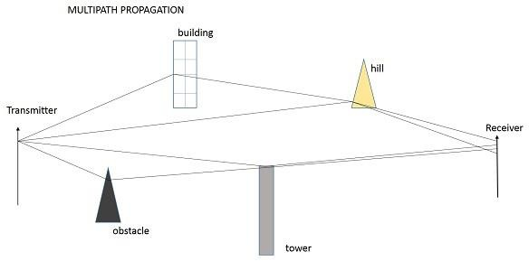The above figure shows an example of multi-path propagation. Multipath propagation is a term, which describes the multiple paths a signal travels to reach the destination. These paths include a number of hops. The paths may be the results of reflection,

refraction or even diffraction. Finally, when the signal from such different paths gets to the receiver, it carries propagation delay, additional noise, and phase differences etc., which decrease the quality of the received output.

### Fading

The decrease in the quality of the signal can be termed as fading. This happens because of atmospheric effects or reflections due to multipath.

Fading refers to the variation of the signal strength with respect to time/distance. It is widely prevalent in wireless transmissions. The most common causes of fading in the wireless environment are multipath propagation and mobility (of objects as well as the communicating devices).

### Skip Distance

The measurable distance on the surface of the Earth from transmitter to receiver, where the signal reflected from the ionosphere can reach the receiver with minimum hops or skips, is known as skip distance.

### Maximum Usable Frequency (MUF)

The Maximum Usable Frequency (MUF) is the highest frequency delivered by the transmitter regardless of the power of the transmitter. The highest frequency, which is reflected from the ionosphere to the receiver is called as critical frequency, fc.

### Optimum Working Frequency (OWF)

The frequency, which is being used mostly for a particular transmission and which has been predicted to be used over a particular period of time, over a path, is termed as Optimum Working Frequency (OWF).

### Inter Symbol Interference

Inter symbol interference (ISI) occurs more commonly in communication system. This is the main reason for signal multipath also. When signals arrive at the receiving stations via different propagation paths, they cancel out each other, which is known as the phenomenon of signal fading. Here, it should be remembered that the signals cancel out themselves in vector way.

### Skin Depth

Electromagnetic waves are not suitable for underwater propagations. However, they can propagate under water provided we make the frequency of propagation extremely low. The attenuation of electromagnetic waves under water is expressed in terms of skin

depth. Skin depth is defined as the distance at which the signal is attenuated by 1/e. It is a measure of depth to which an EM wave can penetrate. Skin depth is represented as δ (delta).